Tree traversals
Y13 - Cambridge International 9618 | Data Structures | Student booklet
Name: _______________________________ | Date: _____________

This booklet has everything you need for the lesson in one place. Work through it in order:
- Learn sections show the key slides. Read them carefully - they explain the ideas and show worked examples.
- Task sections are where you practise. Each task uses what the slides just before it taught you.
- Tasks get harder as you go, and are written like real Cambridge 9618 Paper 4 questions. Task 6 is done at the computer.
Task 1 Retrieval check [5 marks]
Circle True or False for each statement. If a statement is false, write a short correction.
Statement | True | False | Correction if false
A traversal visits every node in the tree exactly once.
A pre-order traversal of an ordered binary tree outputs the data in ascending order.
In a post-order traversal, the root is always the last value output.
A recursive procedure needs a base case, where it stops calling itself.
When a recursive call finishes, the calling procedure starts again from its first line.
Learn Why binary trees?
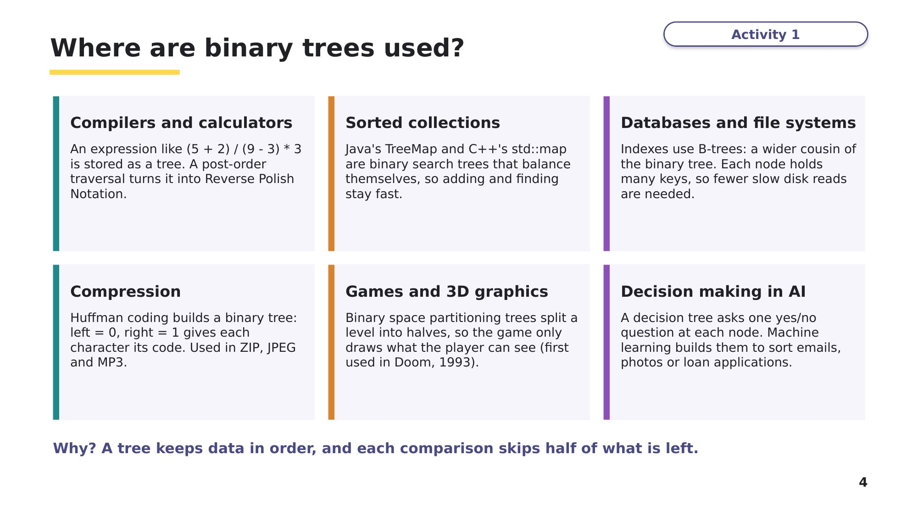
Slide 4 - Where are binary trees used?
Learn Building and storing a tree
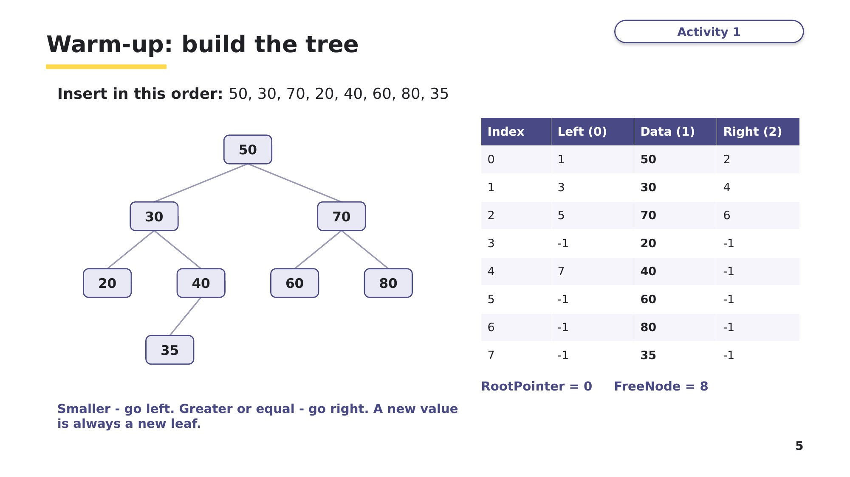
Slide 5 - Warm-up: build the tree
Learn The walk-around method
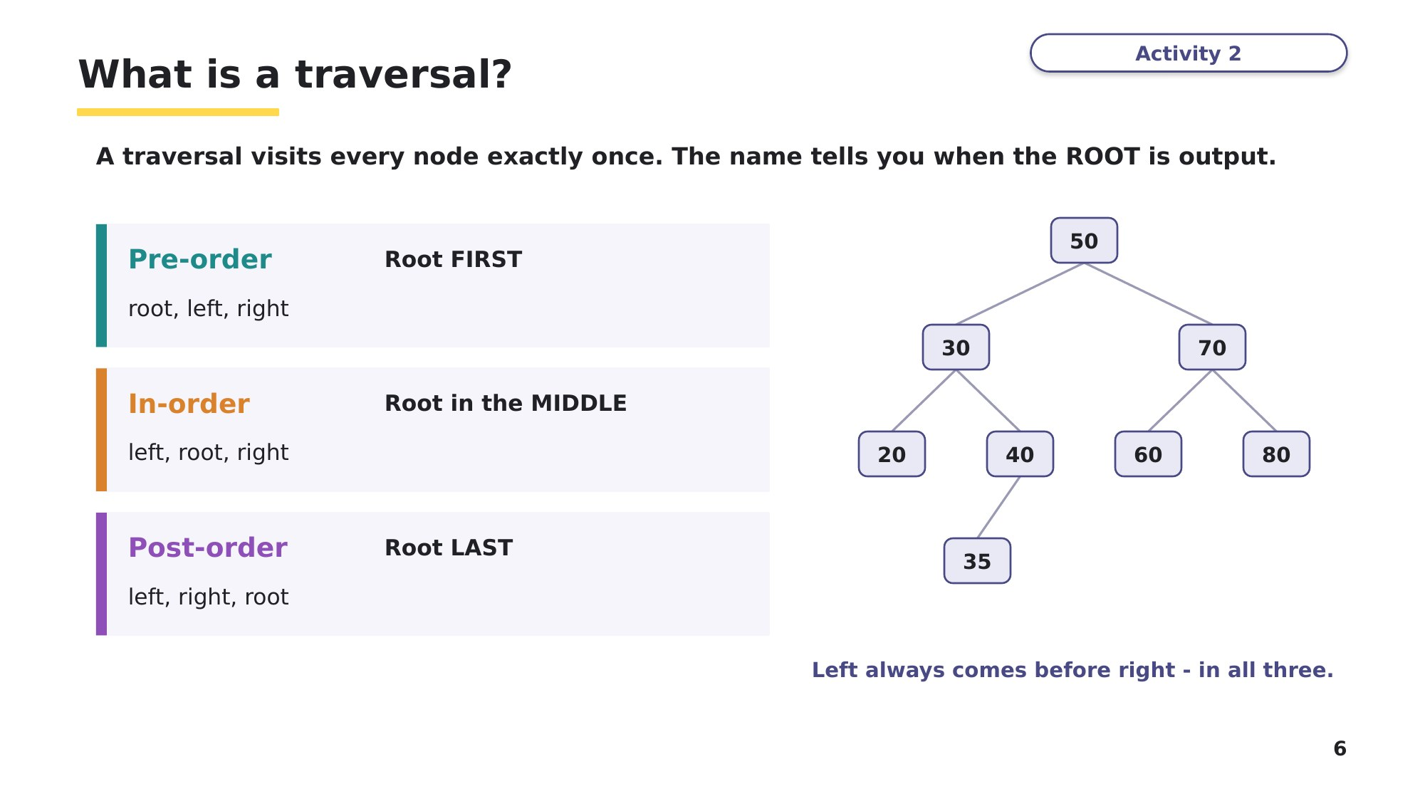
Slide 6 - What is a traversal?
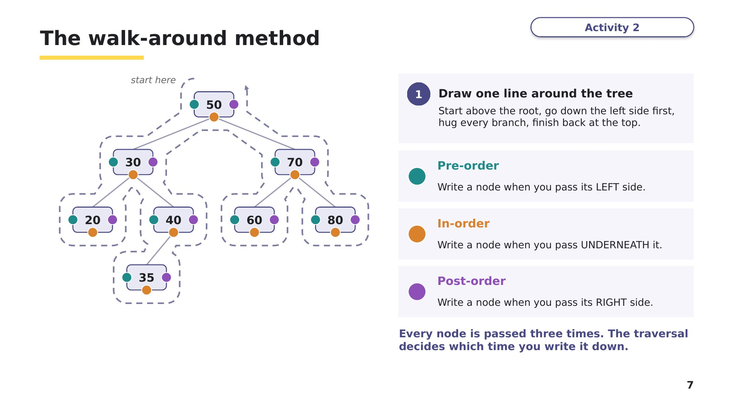
Slide 7 - The walk-around method
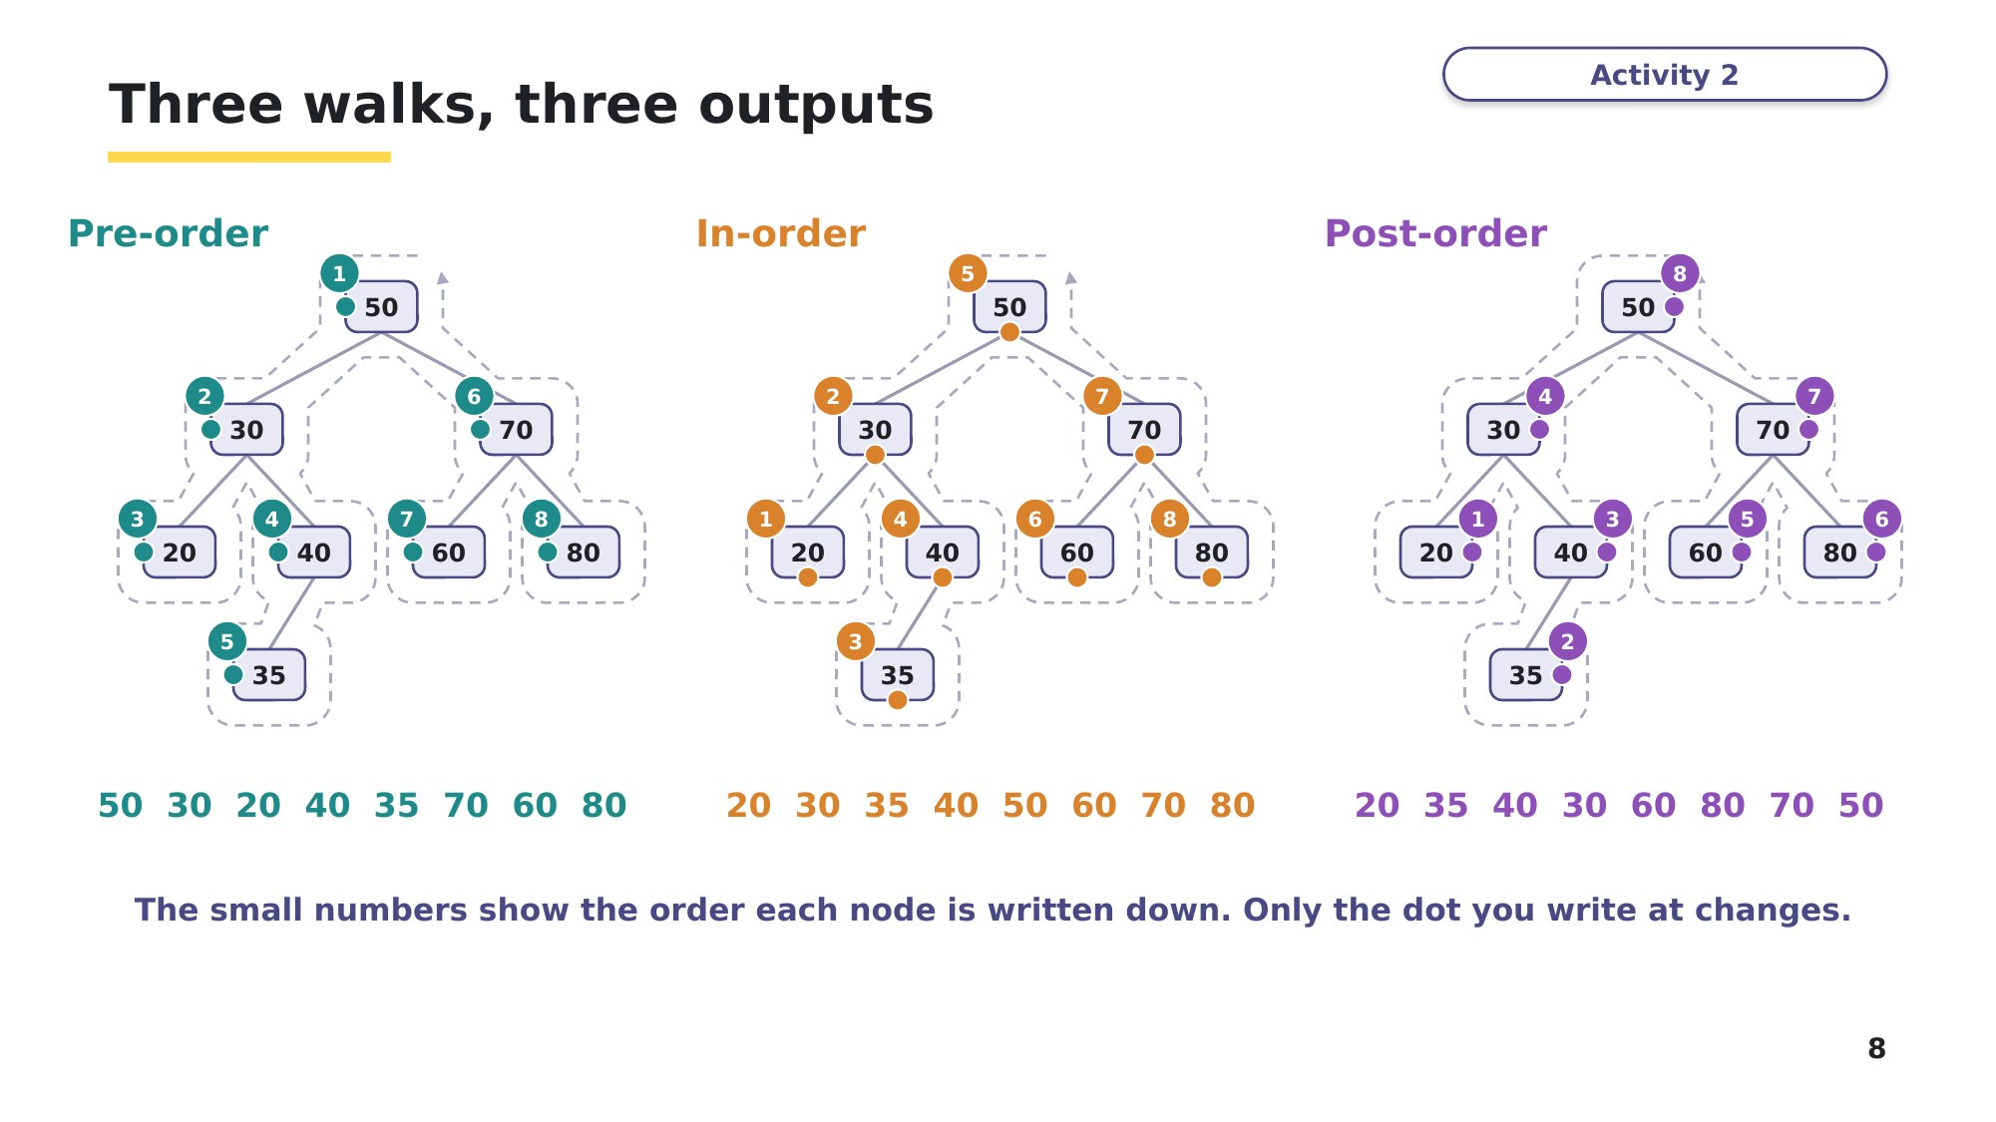
Slide 8 - Three walks, three outputs

Task 2 Draw the tree and traverse it [10 marks]
Based on 9618 Paper 4, November 2021, Q3. The same tree is used in Tasks 3, 4 and 6.
An ordered binary tree stores integers. Smaller values go left; greater or equal values go right. These values are added to an empty tree, in this order:
10, 5, 15, 8, 12, 6, 20, 11, 9, 4
Part A - Draw the tree. [3]

Part B - The tree is stored in the 2D array ArrayNodes. Column 0 is the left pointer, column 1 is the data and column 2 is the right pointer. -1 is a null pointer. Each value is stored in the next free row, in the order it was added. Complete the array, RootPointer and FreeNode. [4]
Index | Left (0) | Data (1) | Right (2)
0 |  | 10
1 |  | 5
2 |  | 15
3 |  | 8
4 |  | 12
5 |  | 6
6 |  | 20
7 |  | 11
8 |  | 9
9 |  | 4
10
RootPointer = ________ FreeNode = ________
Learn Checking your traversals
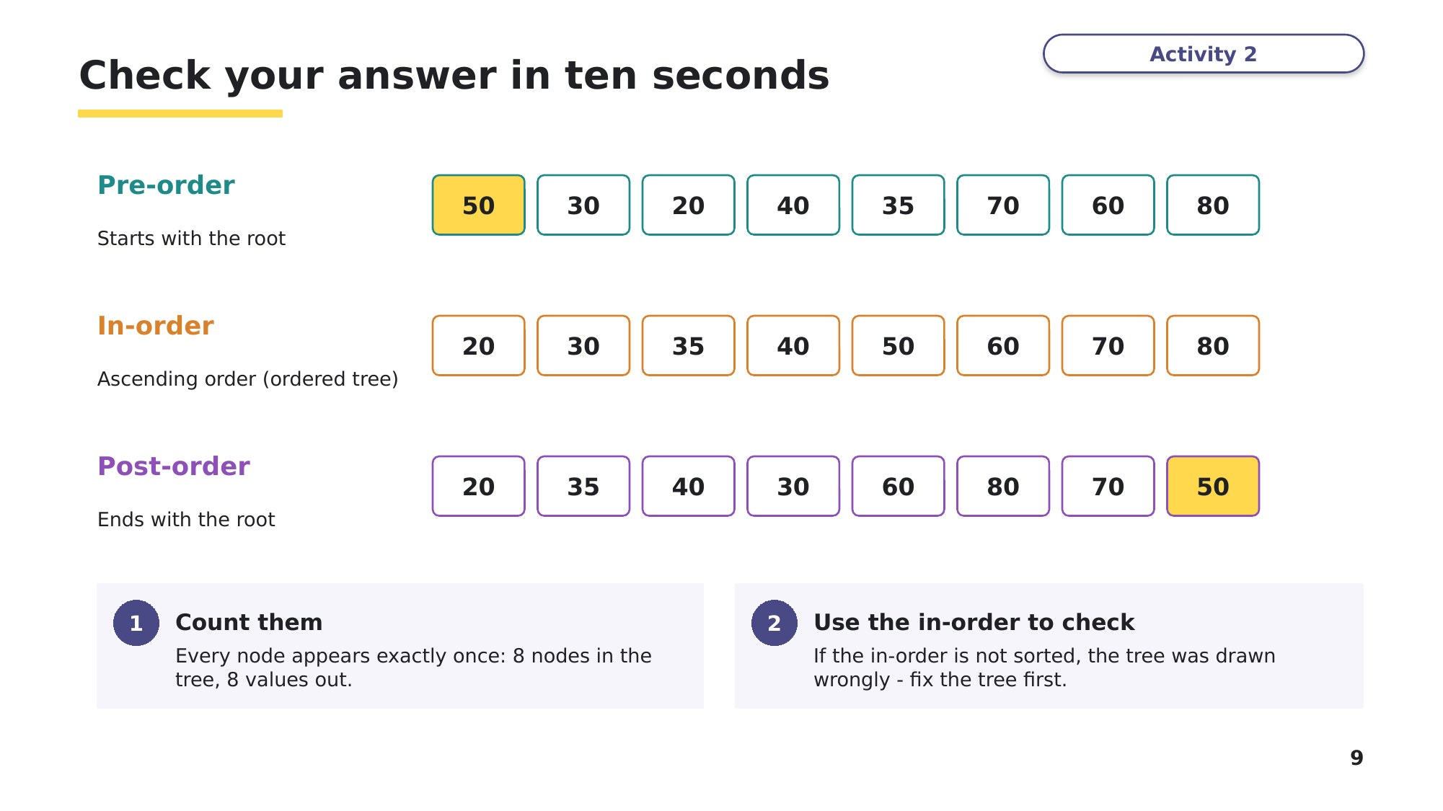
Slide 9 - Check your answer in ten seconds
Part C - Use the walk-around method to write each traversal of the tree. Then do the ten-second checks. [3]
Traversal | Output
Pre-order (root, left, right)
In-order (left, root, right)
Post-order (left, right, root)
Learn Recursion and the call stack
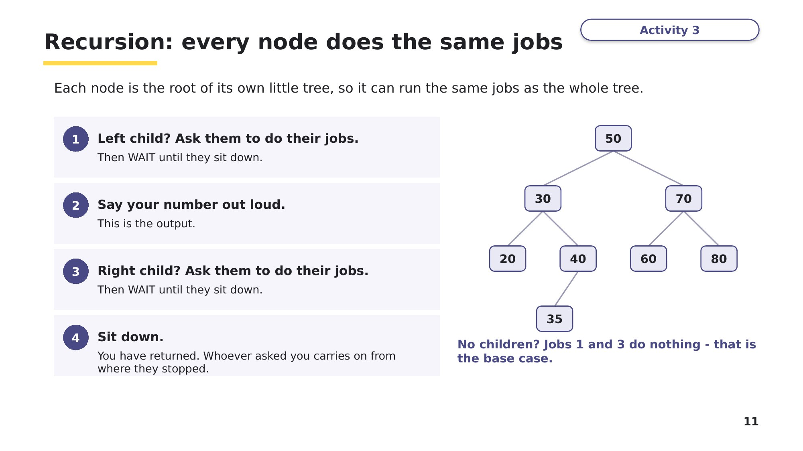
Slide 11 - Recursion: every node does the same jobs
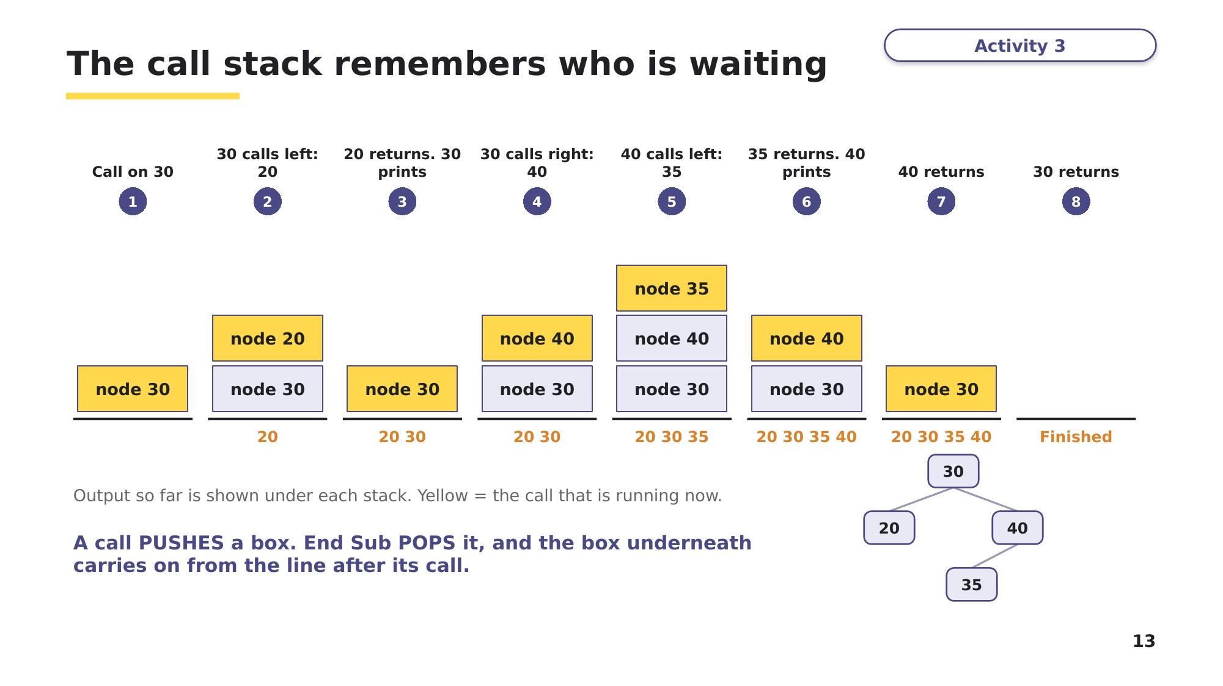
Slide 13 - The call stack remembers who is waiting
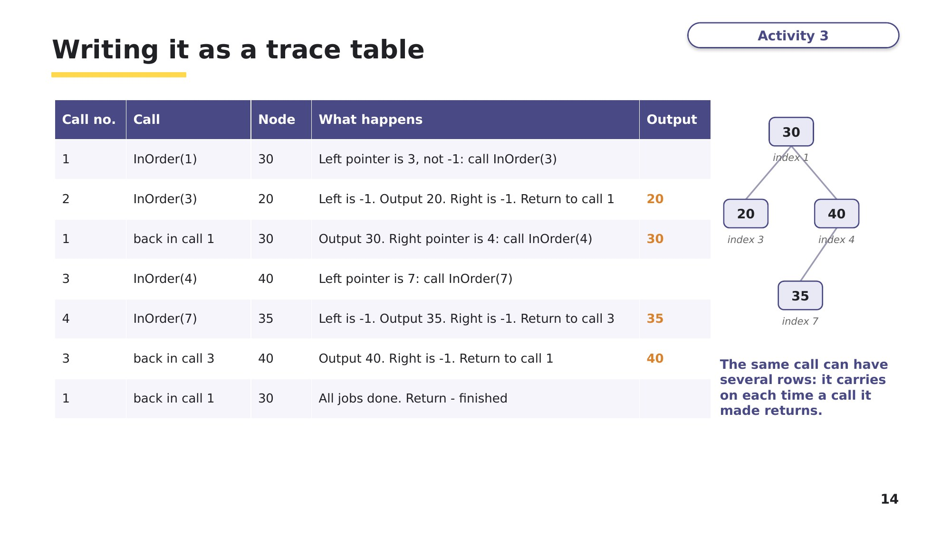
Slide 14 - Writing it as a trace table
Task 3 Trace the recursion [13 marks]
This procedure is used with the ArrayNodes array from Task 2. Root is the index of a node.
Sub PostOrder(ByVal Root As Integer)
If ArrayNodes(Root, 0) <> -1 Then
PostOrder(ArrayNodes(Root, 0))
End If
If ArrayNodes(Root, 2) <> -1 Then
PostOrder(ArrayNodes(Root, 2))
End If
Console.WriteLine(ArrayNodes(Root, 1))
End Sub
Part A - PostOrder(1) is called: it starts at the node holding 5. Complete the trace table. The first two rows are done for you. Use "back in call n" when a call carries on after a call it made has returned. [5]
Call no. | Call | Node | What happens | Output
1 | PostOrder(1) | 5 | Left pointer is 9, not -1: call PostOrder(9)
2 | PostOrder(9) | 4 | Left is -1. Right is -1. Output 4. Return to call 1 | 4

Part B - (i) Draw the call stack at the moment 6 is output. Write the node held by each waiting call, with the first call at the bottom. [1]
Call stack
top
bottom
(ii) When call 4 returns, call 3 carries on. Which part of PostOrder() does call 3 carry on from? [1]

Part C - Explain the reasons why a stack is used when a recursive algorithm is executed. [3]
9618 Paper 3, November 2025 (32), Q12(b)

Part D - State the three essential features of recursion. For each one, show where it is in PostOrder(). [3]
Based on 9618 Paper 3, November 2025 (31), Q9(b)

Learn Check your answers to Task 3 Parts C and D
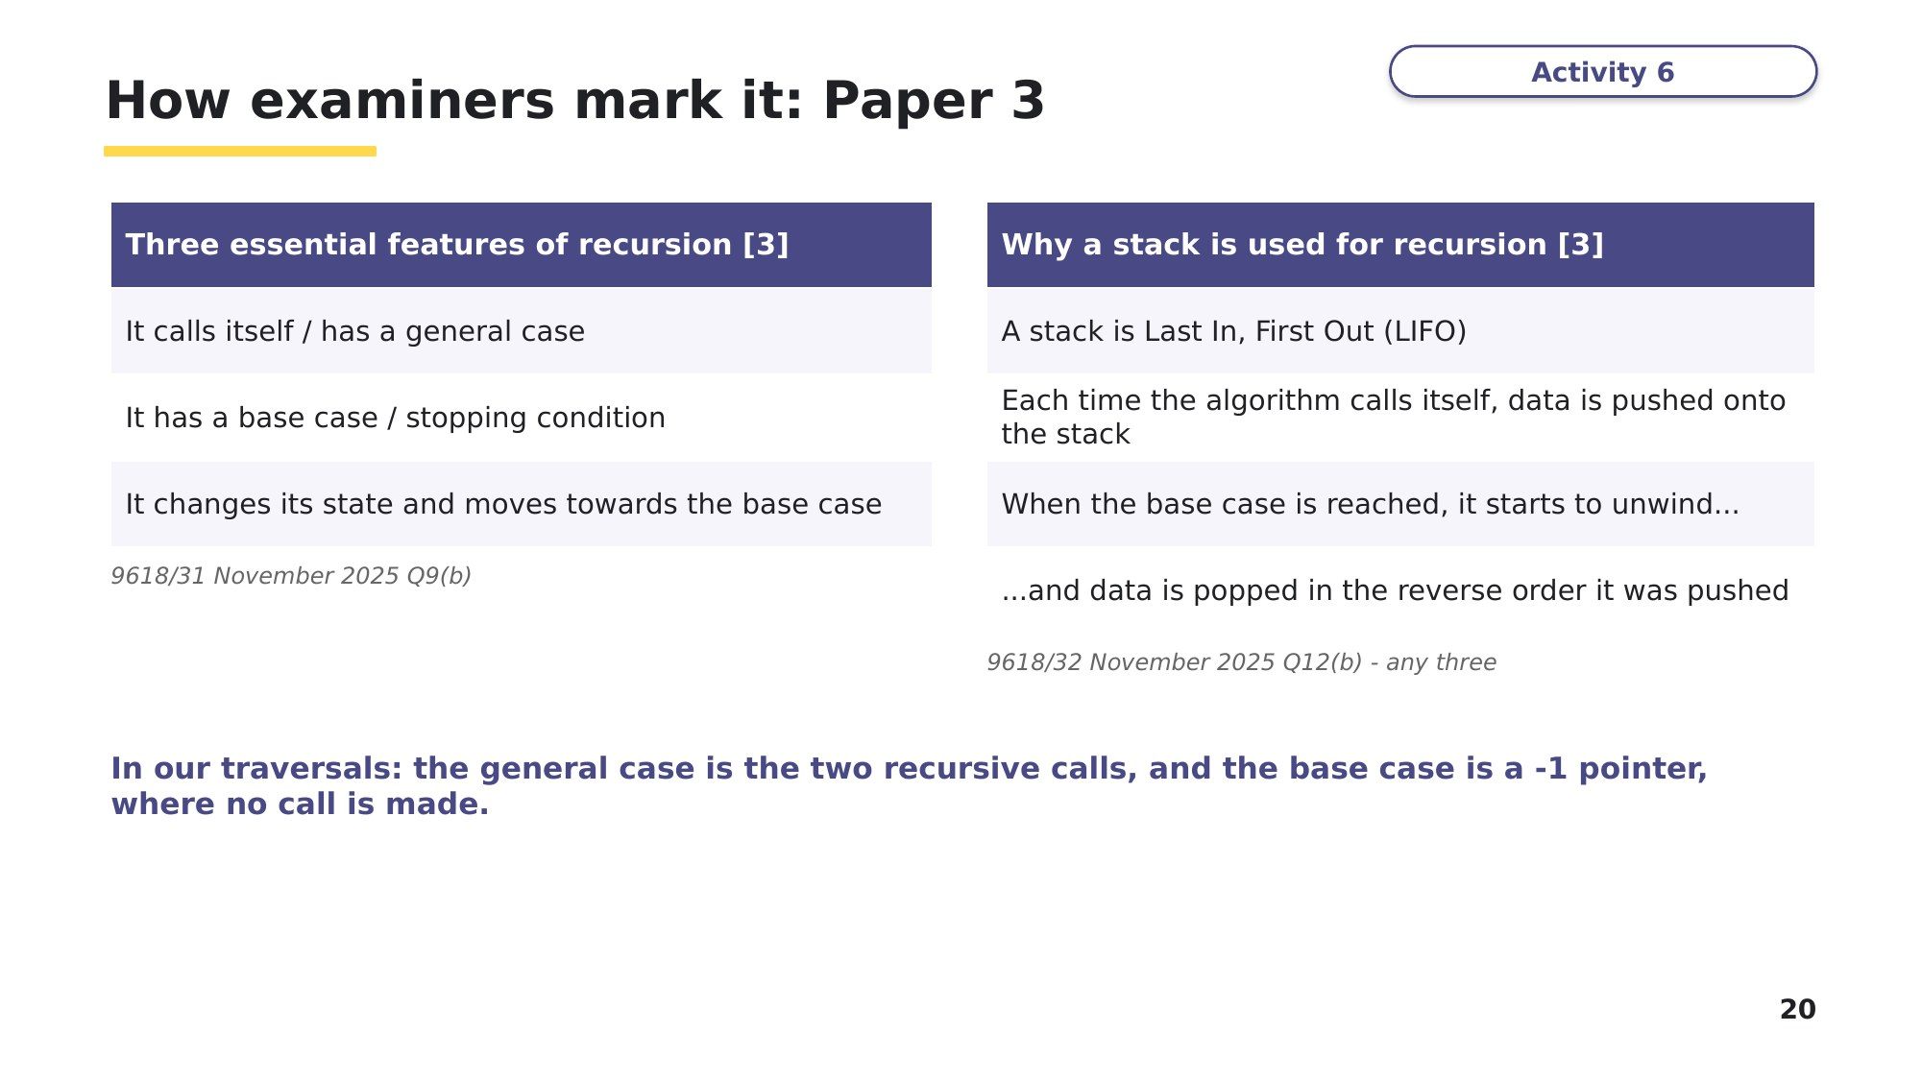
Slide 20 - How examiners mark it: Paper 3
Task 4 Complete and write the code [13 marks]
(a) PreOrder() outputs the data in the tree in pre-order. There are five gaps, numbered (1) to (5). Write the missing VB.NET code for each gap. [5]
Sub PreOrder(ByVal Root As Integer)
Console.WriteLine(ArrayNodes(Root, (1)..........))
If ArrayNodes(Root, 0) <> (2).......... Then
(3)..........(ArrayNodes(Root, 0))
End If
If ArrayNodes(Root, (4)..........) <> -1 Then
PreOrder(ArrayNodes((5).........., 2))
End If
End Sub
(1) ____________ (2) ____________ (3) ____________ (4) ____________ (5) ____________

(b) An in-order tree traversal visits the left node, then the root (and outputs this), then visits the right node.
Write a recursive procedure, InOrder(), to perform an in-order traversal on the tree held in ArrayNodes. [7]
9618 Paper 4, November 2021 (41), Q3(e)(i)

(c) State the output when InOrder() is called on the root of the tree from Task 2. [1]

Learn Check your answers to Task 4
The three traversals are the same procedure with the output line in a different place. Compare your answers with these.
PreOrder() - output FIRST
Sub PreOrder(ByVal Root As Integer)
Console.WriteLine(ArrayNodes(Root, 1))
If ArrayNodes(Root, 0) <> -1 Then
PreOrder(ArrayNodes(Root, 0))
End If
If ArrayNodes(Root, 2) <> -1 Then
PreOrder(ArrayNodes(Root, 2))
End If
End Sub
InOrder() - output in the MIDDLE
Sub InOrder(ByVal Root As Integer)
If ArrayNodes(Root, 0) <> -1 Then
InOrder(ArrayNodes(Root, 0))
End If
Console.WriteLine(ArrayNodes(Root, 1))
If ArrayNodes(Root, 2) <> -1 Then
InOrder(ArrayNodes(Root, 2))
End If
End Sub
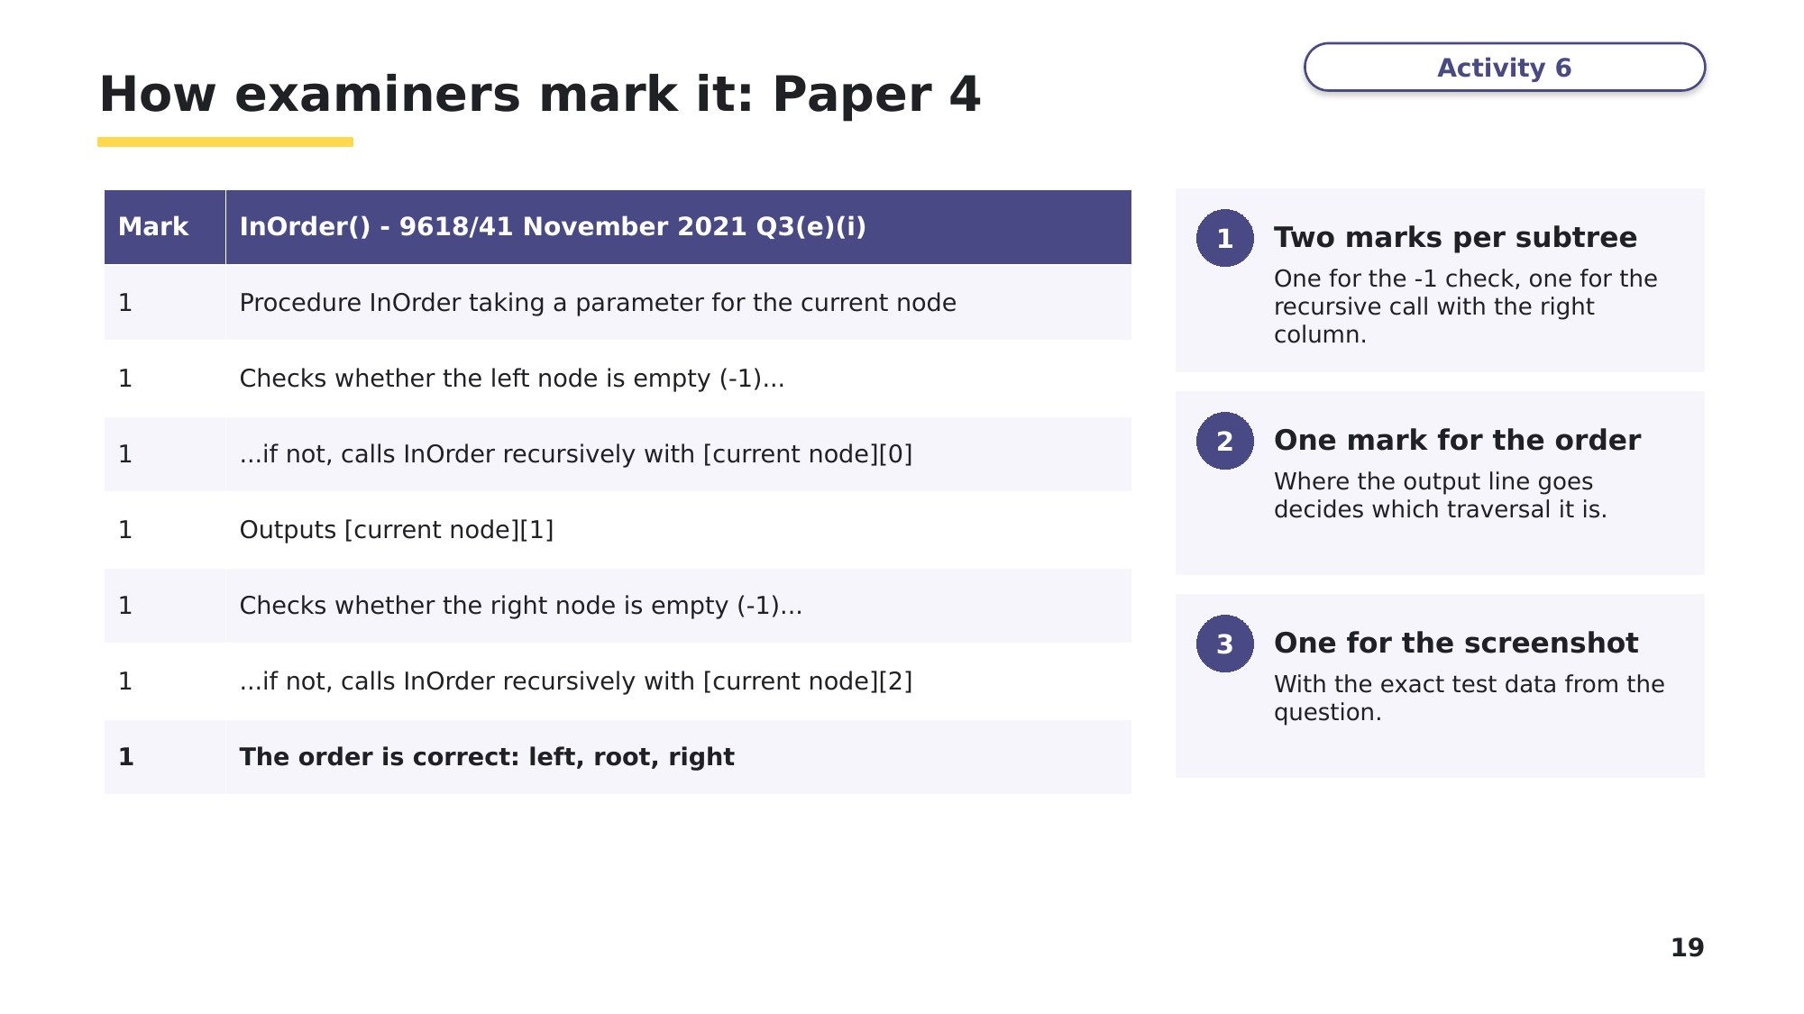
Slide 19 - How examiners mark it: Paper 4
Learn On the way down, on the way back up
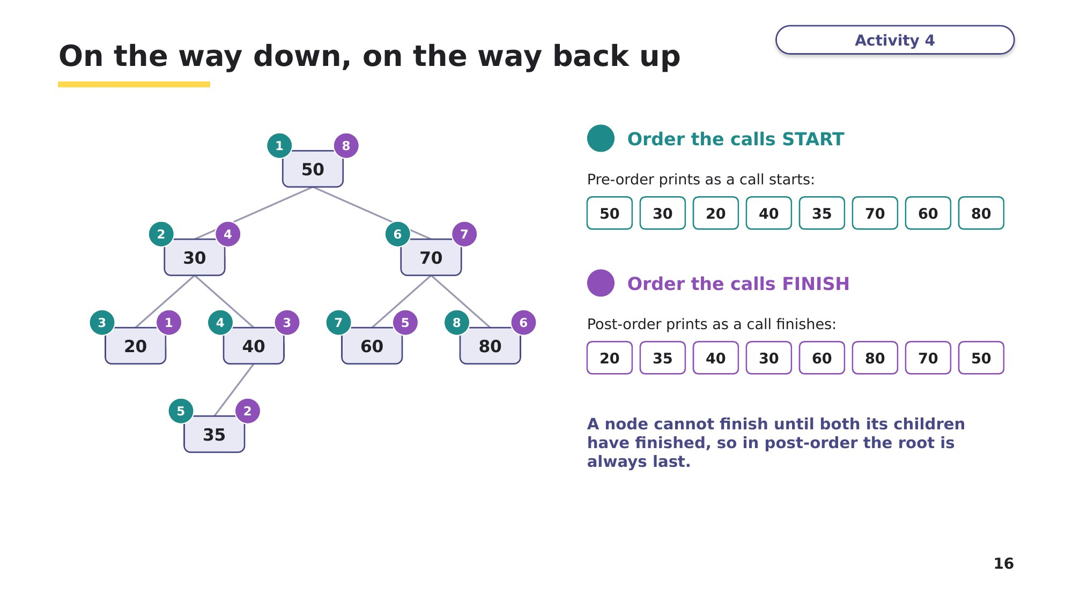
Slide 16 - Pre-order prints as a call starts; post-order prints as it finishes
Task 5 Extension - find and fix the bugs
A student wrote this procedure to output the tree in post-order. It contains TWO errors. For each error, describe what would happen when the procedure runs on the Task 2 tree, and write the corrected code.
Sub PostOrder(ByVal Root As Integer)
PostOrder(ArrayNodes(Root, 0)) ' <-- line A
Console.WriteLine(ArrayNodes(Root, 1)) ' <-- line B
If ArrayNodes(Root, 2) <> -1 Then
PostOrder(ArrayNodes(Root, 2))
End If
End Sub
Error 1 (line A):

Error 2 (line B):

Learn Exam focus
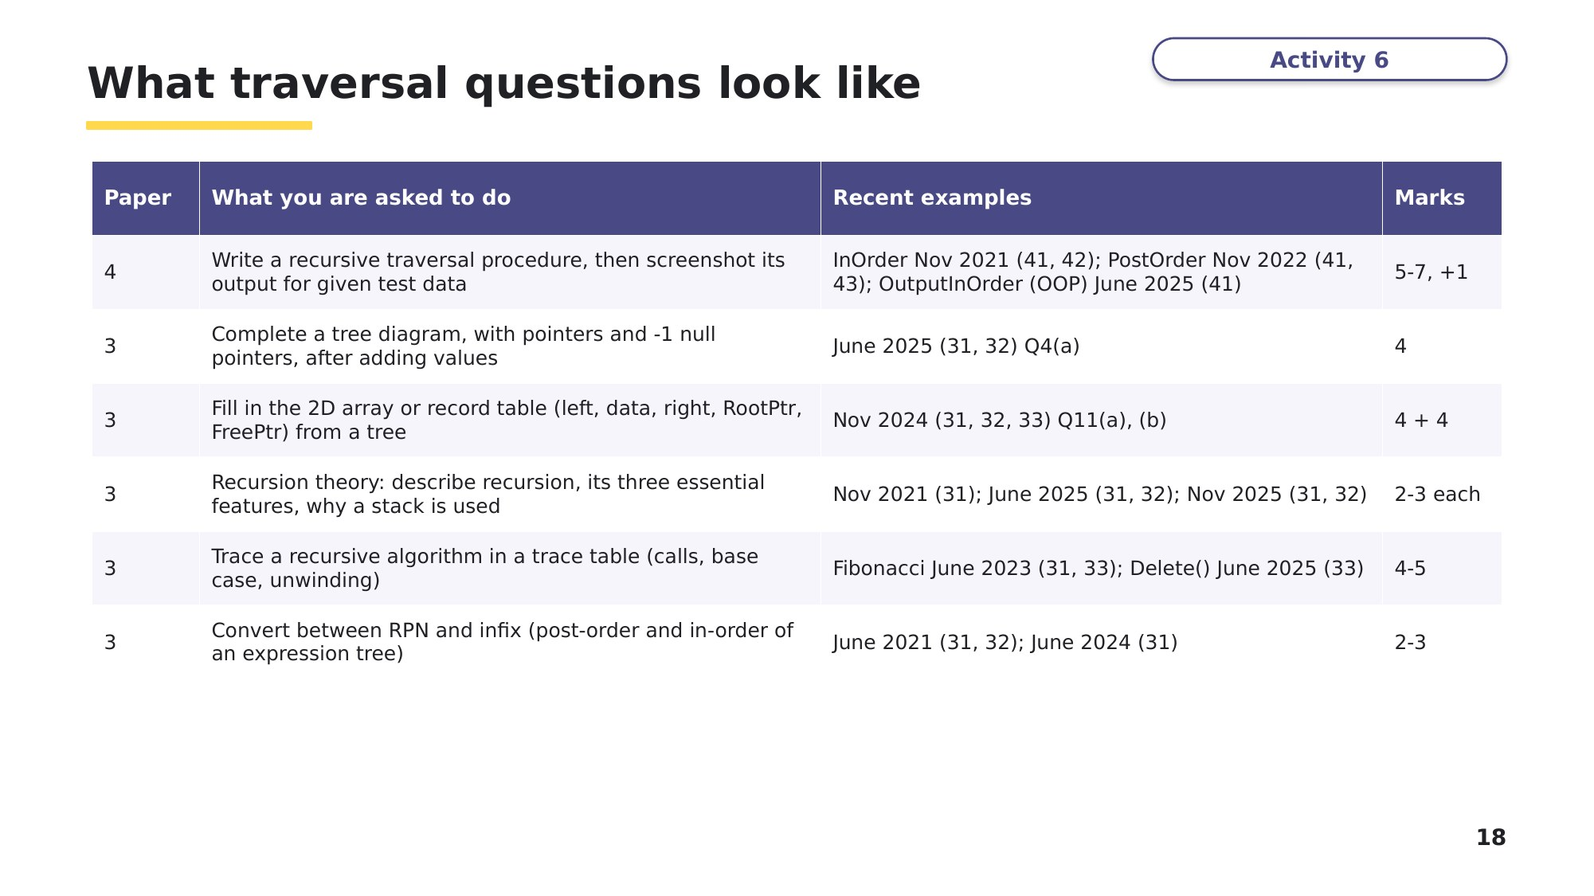
Slide 18 - What traversal questions look like
Task 6 Build it - at the computer [28 marks]
9618 Paper 4, November 2021 (41), Q3. The marks in brackets are from its mark scheme. Create a new VB.NET console application called Question3_N21, and copy your code and screenshots into an evidence document as you go.
An ordered binary tree stores integer data in ascending numerical order. The data is stored in a 2D array: each row is one node, holding a left pointer, the data and a right pointer. The number -1 represents a null pointer.
(a) The 2D array ArrayNodes is declared with space for 20 nodes. Each node has a left pointer, data and right pointer. The program also initialises RootPointer to -1 (null), which points to the first node in the tree, and FreeNode to 0, which points to the first empty node in the array. Write program code to declare ArrayNodes, RootPointer and FreeNode in the main program. [4]
(b) The procedure AddNode() adds a new node to ArrayNodes. It takes the array, root pointer and free node pointer as parameters, asks the user to enter the data and reads it in, adds the node as the root if the tree is empty, and otherwise follows the pointers to find the position for the new data. There are six incomplete statements in the pseudocode. Write program code for AddNode(). [8]
PROCEDURE AddNode(BYREF ArrayNodes[] : ARRAY OF INTEGER,
BYREF RootPointer : INTEGER, BYREF FreeNode : INTEGER)
OUTPUT "Enter the data"
INPUT NodeData
IF FreeNode <= 19 THEN
ArrayNodes[FreeNode, 0] ← -1
ArrayNodes[FreeNode, 1] ← ....................
ArrayNodes[FreeNode, 2] ← -1
IF RootPointer = .................... THEN
RootPointer ← 0
ELSE
Placed ← FALSE
CurrentNode ← RootPointer
WHILE Placed = FALSE
IF NodeData < ArrayNodes[CurrentNode, 1] THEN
IF ArrayNodes[CurrentNode, 0] = -1 THEN
ArrayNodes[CurrentNode, 0] ← ....................
Placed ← TRUE
ELSE
.................... ← ArrayNodes[CurrentNode, 0]
ENDIF
ELSE
IF ArrayNodes[CurrentNode, 2] = -1 THEN
ArrayNodes[CurrentNode, 2] ← FreeNode
Placed ← ....................
ELSE
CurrentNode ← ArrayNodes[CurrentNode, 2]
ENDIF
ENDIF
ENDWHILE
ENDIF
FreeNode ← .................... + 1
ELSE
OUTPUT("Tree is full")
ENDIF
ENDPROCEDURE
(c) The procedure PrintAll() outputs the data in each element of ArrayNodes, in the order they are stored in the array. Each element is printed on one row in the order LeftPointer, Data, RightPointer, with spaces between, for example "1 20 -1". Write program code for PrintAll(). [4]
(d)(i) The main program loops 10 times, each time calling AddNode(). It then calls PrintAll(). Edit the main program to do this. [3]
(d)(ii) Test the program by entering the data 10, 5, 15, 8, 12, 6, 20, 11, 9, 4. Take a screenshot of the output. [1]
Predict first: which rows of PrintAll() have you already worked out? Check your screenshot against Task 2 Part B.
(e)(i) Write the recursive procedure InOrder() to perform an in-order traversal on the tree held in ArrayNodes (your answer to Task 4(b)). Because ArrayNodes is declared in the main program, pass the array to InOrder() as a parameter, as you did for AddNode(). [7]
(e)(ii) Test InOrder() with the same data as (d)(ii) and take a screenshot. [1]
Predict first - the output will be:

Stretch 1 - the other two traversals
Add PreOrder() and PostOrder() to your program and call both on the root after InOrder(). Predict each output first (your Task 2 Part C answers), then take a screenshot.
Pre-order prediction:

Post-order prediction:

Stretch 2 - recursive functions that return a value (not from a past paper)
Write a recursive function CountNodes(ArrayNodes, RootNode) that returns the number of nodes in the tree, and a recursive function Height(ArrayNodes, RootNode) that returns the number of levels in the tree. Hint: for each function, decide what to return when RootNode is -1 (the base case), then combine the answers for the left and right subtrees. Predict both results for the Task 2 tree before you run them.
CountNodes prediction: ________ Height prediction: ________
Learn Review
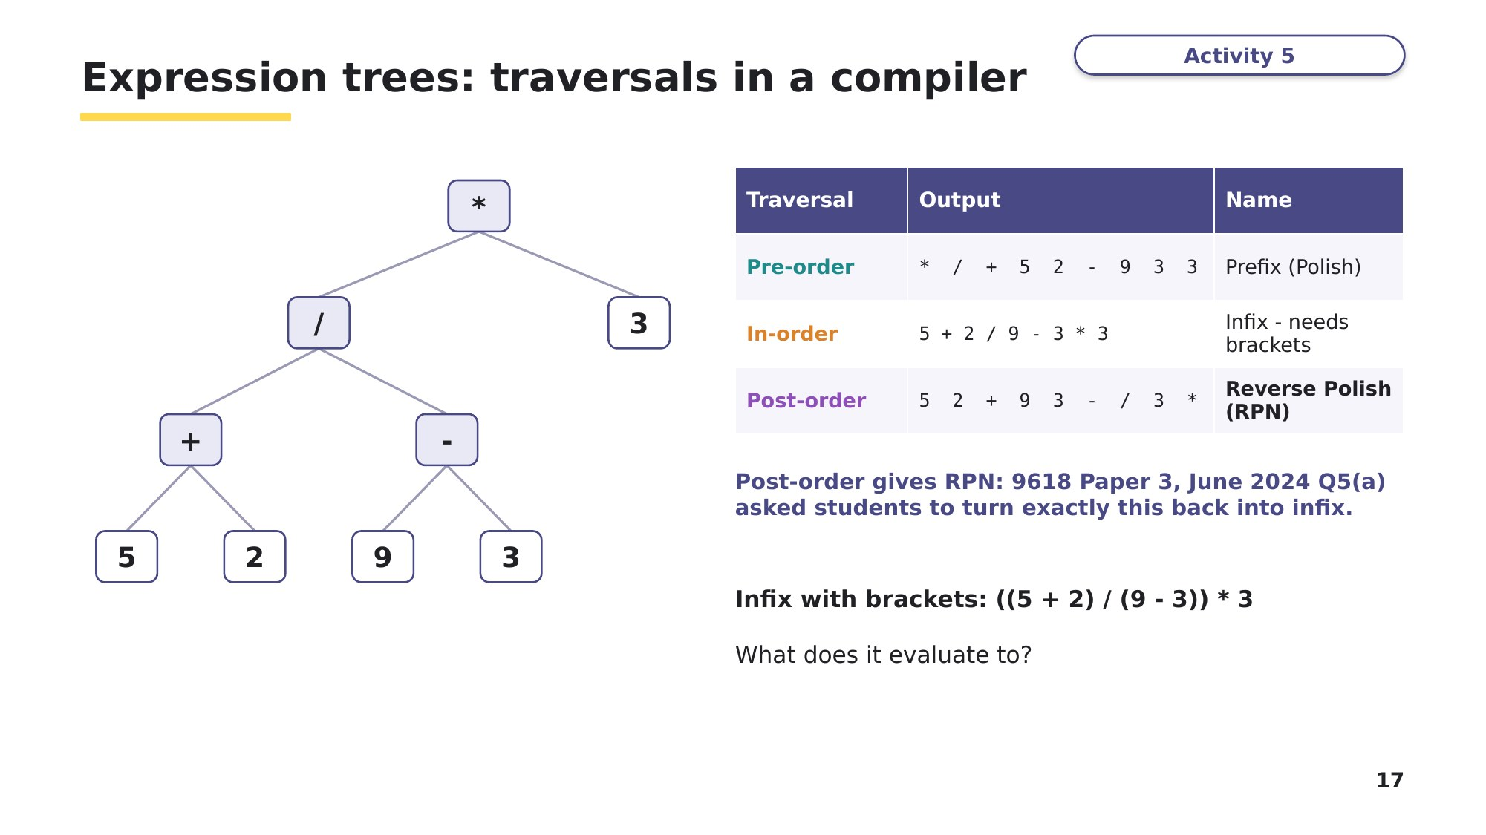
Slide 17 - Going further: expression trees in a compiler
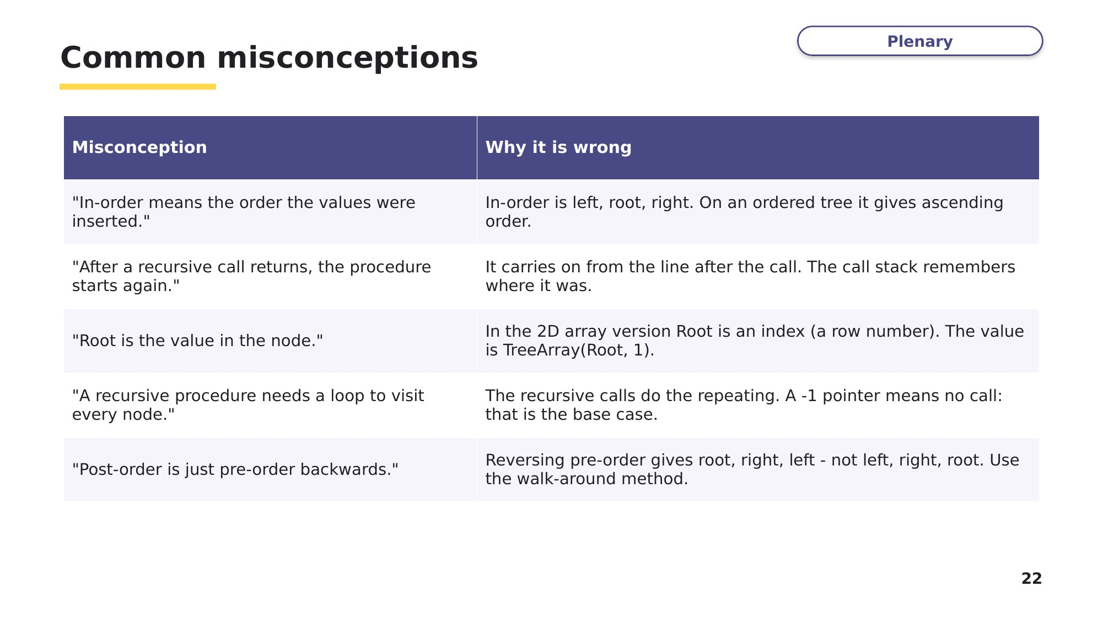
Slide 22 - Common misconceptions
Look back at your Task 1 answers. Would you change any of them now? Write any corrections in a different colour.
Learn Exit question
These values are added to an empty tree, in order: 40, 20, 60, 10, 30, 25.
1. Draw the tree.
2. Write the post-order traversal.

3. PostOrder() is called on the root. Draw the call stack at the moment 25 is output.
Call stack
top
bottom

